UP HOLLAND PARISH COUNCIL

Notice of Conclusion of Audit

Annual Governance & Accountability Return for the Year ended 31 March 2019

Section 20(2) and 25 of the Local Audit and Accountability Act 2014
Accounts and Audit Regulations 2015 (SI 2015/234)

The audit of accounts for UP HOLLAND PARISH COUNCIL for the year ended 31 March 2019 has been completed and the accounts have been published

The Annual Governance & Accountability Return is available for inspection by any local government elector of the area of Up Holland Parish Council on written application to the Clerk at the address below.
The requisite information as defined by the Accounts and Audit Regulations 2015 is displayed alongside this notice

Copies can be supplied to any person on application to the address below on payment of £5.00 for each copy of the Annual Govenance and Accountability Return

Dated: 26 September 2019

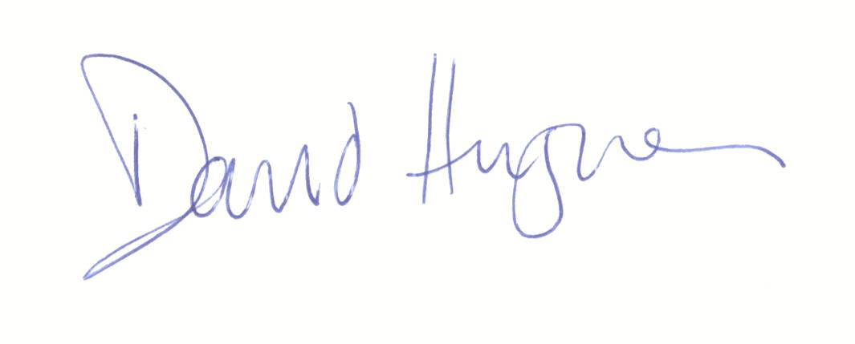
Signed…………………………………………………………………………………

Clerk to the Parish Council and Responsible Financial Officer

10 The Nook, Appley Bridge, Lancs, WN6 9JB

